# Office to PDF Conversion Guide

Simply pass in a file name argument/parameter (Word or Excel document) and have a PDF created for you. If the file name or path has spaces in it, put the entire argument in double quotes. The PDF will be created in the same location as the original file (given that you have access).

Examples:

\\sqlrdp\artifacts\prod\com.pharmmd.com.OfficeToPDFConversions\PDFConverter\bin\Release\PDFConverter.exe “\\sqlrdp\client files\mywordfile.doc”

\\sqlrdp\artifacts\prod\com.pharmmd.com.OfficeToPDFConversions\PDFConverter\bin\Release\PDFConverter.exe “\\sqlrdp\client files\yourtest\michael jordan.xlsx”

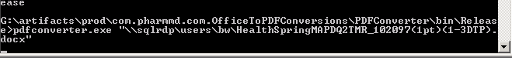

Office must be installed n the calling machine to reach the libraries.

Currently the following file types are valid inputs

* .doc
* .docx
* .xls
* .xlsx